Can I describe a picture? Name:
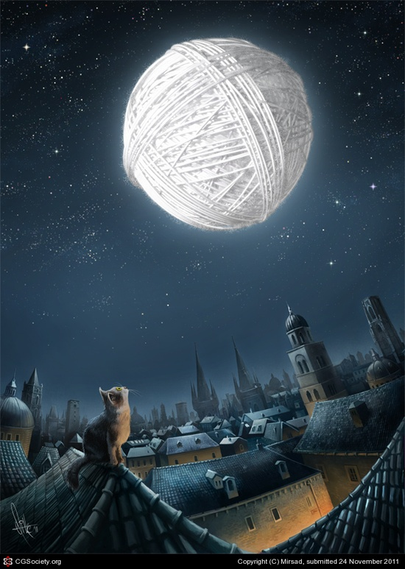 | moon  houses  string  wool  yarn  castles  church  tower  roof  window  tiles  stars  glowing

 |  |  | ABC |  | 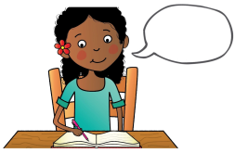
pencil grip | say the sentence | finger spaces | capital letters | full stops | read your writing

