Independent Writing | Name:
Can I describe a picture?
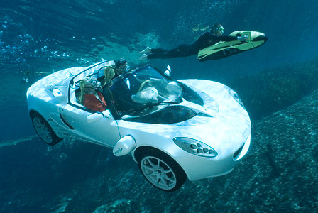

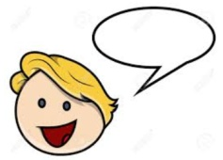 | 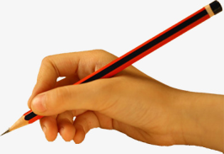 | ABC |  |  | 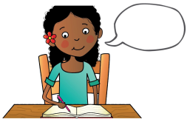
say the sentence | baby bird | capital letters | finger spaces | full stops | read your writing
headlights wheels people masks seascooter diver bubbles

