Year 3 Summer Term 2

Homework Project

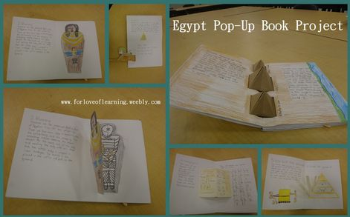

**Exciting**

**Egypt**

This half term, we’re learning all about Ancient Egypt!

Your project homework is to make an information book all about Ancient Egypt. In your book, you need to include facts about pharaohs, mummies, Howard Carter and anything else that you can remember!

Be creative and have fun with this project!

**Due date: Friday 24th May 2019**

*Here are some places that might help you with your project:*

* Google
* Youtube
* Pinterest
* Twinkl