Year 6 Christmas stockings
For Design and technology, Year 6 have been making Christmas stockings. They have been practising a lot of sewing. They’re ready and steady, and their results are going to look great! Here are some pictures below:
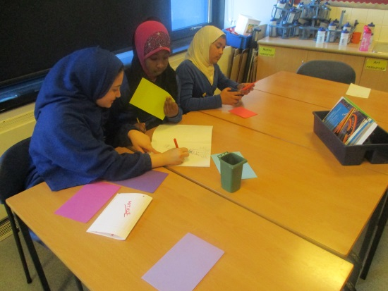
By Fatima and Tafiyah (year 6 digital leaders)

