Learning Today, Leading Tomorrow
School Council Members Spring 2016
 | Class | Name
Year 1 | Jamaica | - Ruqayyah  - Abdullah | 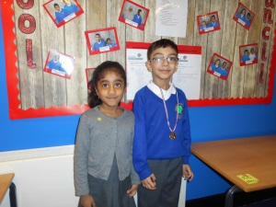
 | India | - Aisha  - Mykolas | 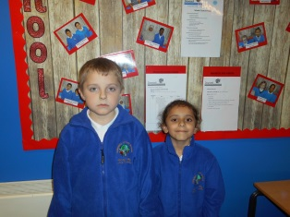
 | Morocco | - Samsor  - Amna | 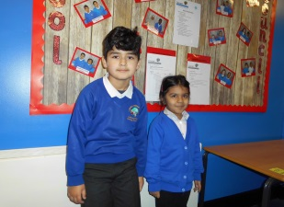
Year 2 | Kosovo | - Sonia  - Taaseen | 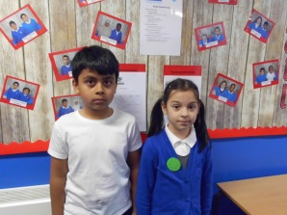
 | Brazil | - Ibrahim  - Hope | 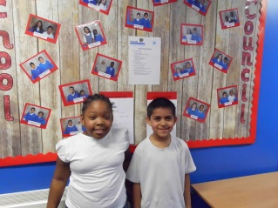
 | New Zealand | - Alex  - Arwa | 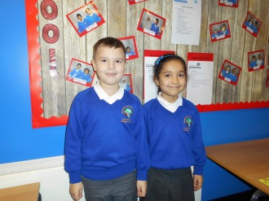
Year 3 | Gibraltar | - Xue  - Evin | 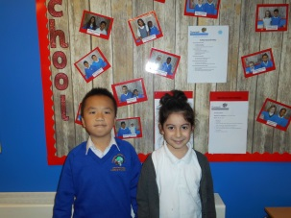
 | Ireland | - Mehmet  - Mara | 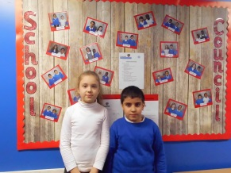
 | Norway | - Amnah  - Jin | 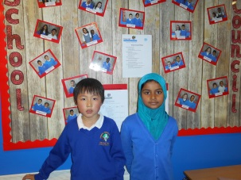
Year 4 | UAE | - Umar  - Sofia | 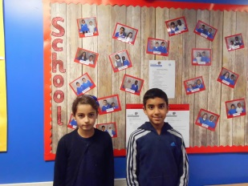
 | Pakistan | - Sakina  - Rayan | 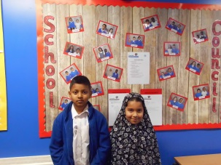
 | France | - Max  - Wiktoria | 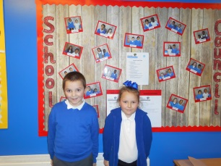
Year 5 | Malaysia | - Eden  - Haris | 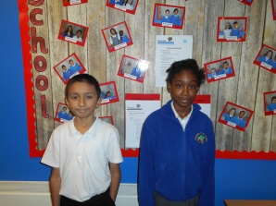
 | Egypt | - Jahnae  - Nathan | 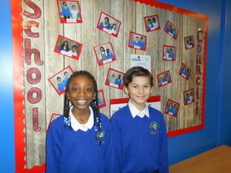
 | America | - Cinar  - Alisha | 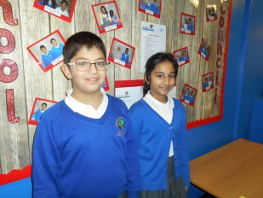
Year 6 | China | - Nisha  - Jacob | 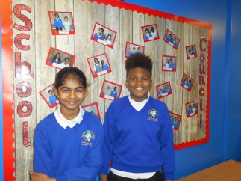
 | South Africa | - Fatima A  - Ethan | 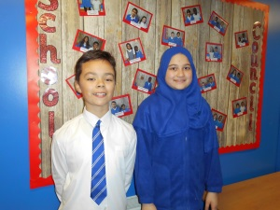
 | Spain | - Dionisio  - Tameka | 