Phonics – Summer 2 Week 5 – 29.06.2020
*All worksheets can be found below.
Practice your sounds daily – set 1, 2 and 3 sounds
https://www.oxfordowl.co.uk/for-home/reading-owl/find-a-book/read-write-inc-phonics--1/phonics-pure-sounds-video
1 | ‘aw’ work sheet – practice reading the ‘aw’. When reading one of your books, can you spot some words that have the ‘aw’ sound?
2 | As yesterday  Write some sentences using these words – claw, straw, dawn
3 | ‘are’ worksheet – practice reading the ‘are’. Look around your home. How many words can you find with the ‘are’ sound around your house?  https://www.youtube.com/watch?v=32mNG3itSRM
4 | As yesterday  Write some sentences using these words – bare, share, care
*Remember to read a book each day - either a book that you have at home or one of the e-books online. https://www.oxfordowl.co.uk/for-home/find-a-book/library-page/

Have a go at these green words!
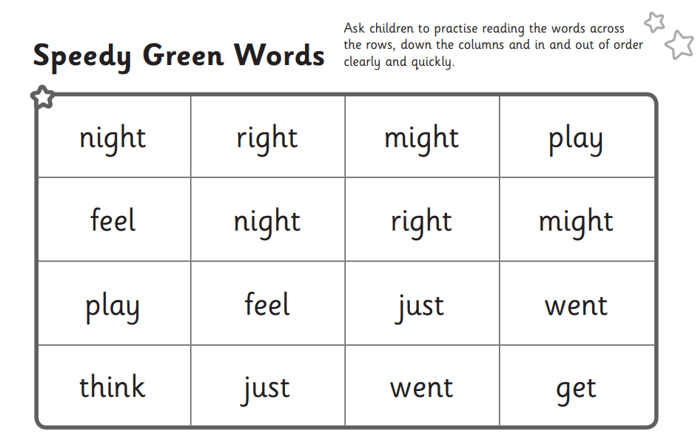

- aw worksheet
