Phonics – Summer 2 Week 6 – 06.07.2020
*All worksheets can be found below.
Practice your sounds daily – set 1, 2 and 3 sounds
https://www.oxfordowl.co.uk/for-home/reading-owl/find-a-book/read-write-inc-phonics--1/phonics-pure-sounds-video
1 | ‘ur’ work sheet – practice reading the ‘ur’. When reading one of your books, can you spot some words that have the ‘ur’ sound?  https://www.youtube.com/watch?v=6VqTTnhE2LQ
2 | As yesterday  Write some sentences using these words – burn, surf, hurt
3 | ‘er’ worksheet – practice reading the ‘er’. Look around your home. How many words can you find with the ‘er’ sound around your house?  https://www.youtube.com/watch?v=Xd2e2_wA5Vk
4 | As yesterday  Write some sentences using these words – herd, ferb, herb
*Remember to read a book each day - either a book that you have at home or one of the e-books online. https://www.oxfordowl.co.uk/for-home/find-a-book/library-page/

Have a go at these green words!
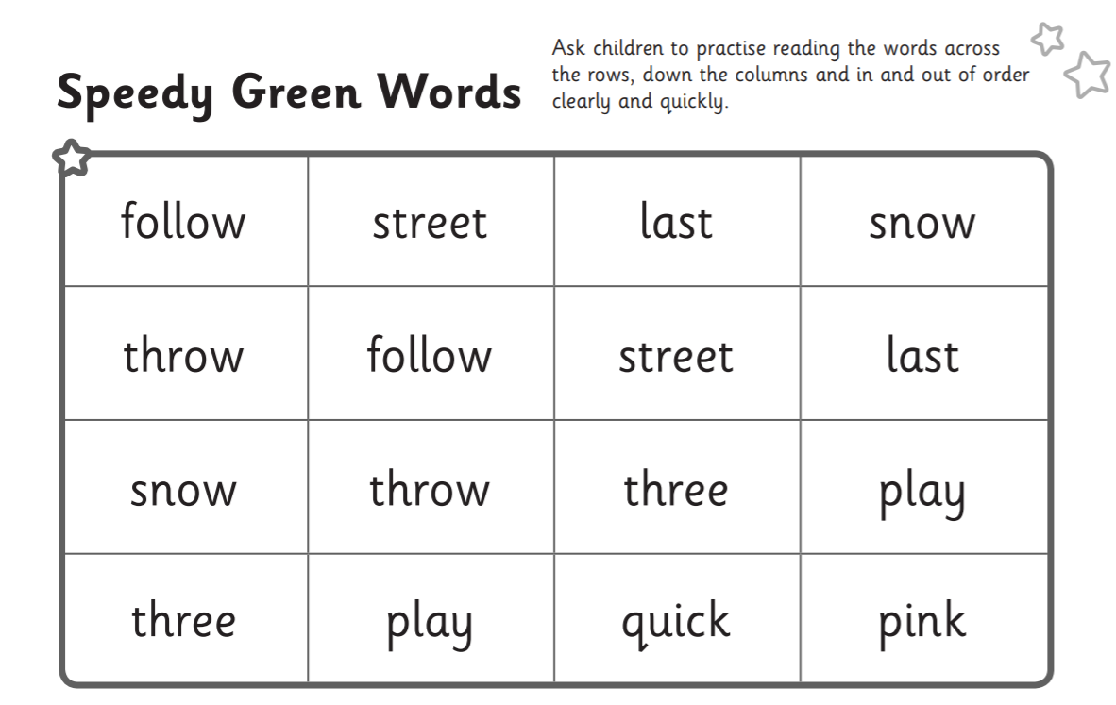

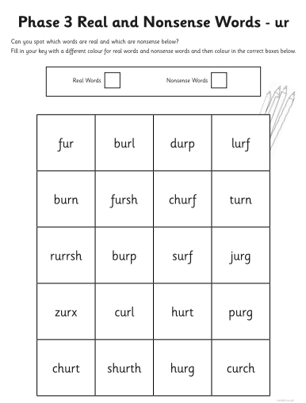
- ur worksheet

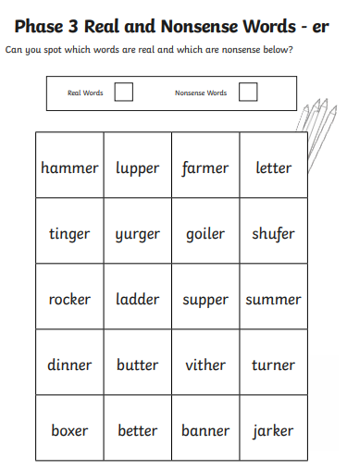
- er worksheet

