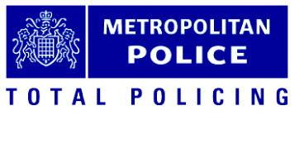
Waltham Forest Junior Citizens Event

Health and Permission Form

Junior Citizen Scheme 2020

Venue: Downsell Primary School
Date: 16th July 2020

Activity: The Waltham Forest Junior Citizen program provides children with the skills and confidence needed to effectively handle any emergency situations with developing responsible attitudes and behavior towards and others and preventing crime. The 5 scenarios cover a wide range of issues and encourage the children to think through problems they are confronted with and resolve them successfully and safely.

Participant Details

Family Name: Forename:

Address:

Date of birth: Age:

Emergency Contact

Name: Relationship:

Address: Contact No:

Medical Details

Doctor’s Name: Telephone No:

Address:

Is HE/SHE allergic to anything (e.g. antibiotic, particular food or medication) Yes No

If YES, please give details

Is HE/SHE receiving any medical treatment? Yes No

Is HE/SHE taking any form of prescribed medication? Yes No

Is YES, please provide details:

PLEASE NOTE: All medication required should be given to the first-aid staff (minimum ELS standard) and clearly marked with the participant’s name and full instructions for use (except for inhalers, which may be retained by the participant). Medication will not be physically administered by our staff. The participant should be capable of self-administering their own medication. We will only look after it and make it available for them to use unless there is a staff member at school who is authorised by you to do this.

Is there any other information you wish to inform us about that may have an impact on your son/daughter/ward* ability to take part in this event or activity? Yes No

If YES, please provide details:

Please give any details of any special dietary requirements here: (a snack of fruit and drink are provided)

Permission for Photography/Filming

Yes No

I consent to pictures/film of my son/daughter/ward* being used in publicity for the Metropolitan Police Service, the Metropolitan Police Authority and the working partners at this event.

This publicity may include:

* Use in static displays at exhibitions and conference; * Use in static displays in public places, including libraries;
* Station Open Days; * Use in local newspaper articles;
* Use in national newspaper and magazine articles; * Use on company social media e.g. Twitter
* Use in internal police publications.

Emergency Permission

In the event that medical staff considers that immediate treatment is essential and the delay in contacting me is likely to prejudice recovery, I authorise MPS staff to give permission to the doctor to undertake whatever treatment is considered necessary.

Permission to Take Part

- I consent (for my son/daughter/ward∗) to take part in the above activity.
- I am fully aware of the type and extent of the activity.
- The information I have supplied above is true to the best of my knowledge.
- I have been able to access the risk assessment. (Available from the MPS staff organising.)
- I am aware of the extent of the insurance cover. (Available from the MPS staff organising.)

* delete as applicable

Signed (Parent/Guardian):…………………………………………………………………………………………………………………………………………………………………………

Print Name:……………………………………………………………………………………………………………………………………………………………………………………………………….

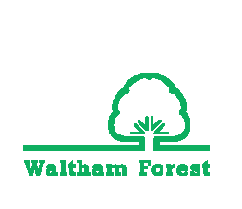
Date:…………………………………………………………………………………………………………………………………………………………………………………………………………………….
YIAG

