Finance Department  The Benefit Service | Confidential | 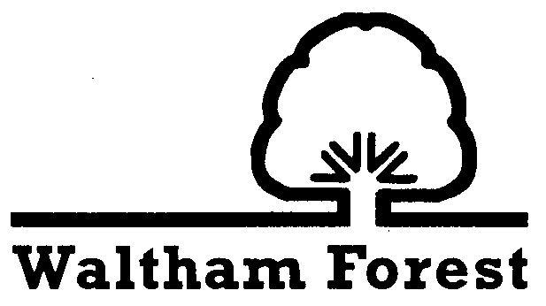

APPLICATION FOR FREE SCHOOL MEALS

If you would like your child to receive free school meals, please fill in this form (using CAPITAL letters) and drop it off at Walthamstow Customer Service Centre or one of the following libraries Leyton/ Leytonstone/ North Chingford/ Walthamstow. Alte

rnatively, post it to:

The Benefits Service  London Borough of Waltham Forest  PO Box 856  London. E17 9PN |  |  |  |  |  |  |  |  |  |  | For office use only
Your details
Your first name |  |  |  |  |  |  |  |  |  | Title (Mr, Mrs, Miss, Ms)
Your last name |  |  |  |  |  |  |  |  |  | Date of birth
Your National insurance / NASS Reference number
Your partner’s details (if applicable)
Your partner’s first name |  |  |  |  |  |  |  |  |  | Title (Mr, Mrs, Miss, Ms)
Your partner’s last name |  |  |  |  |  |  |  |  |  | Date of birth
Your partner’s National insurance / NASS Reference number
Your/ your partner’s address
 |  |  |  |  |  |  |  |  |  | Postcode

Contact details
Telephone number |  |  | Mobile

Email

Please tick the income you/your partner receive
Income Support
Income-based Jobseeker’s Allowance
Income-related Employment and Support Allowance
The Guarantee Credit element of State Pension Credit
Support from the National Asylum Support Service (NASS)
Support from the local authority Social Services Asylum Team (SSAT)

Child Tax Credit provided you are not entitled to Working Tax Credit and have an annual income (as assessed by HM Revenue & Customs) that is £16,190 or less - this figure changes each year

Working Tax Credit for four weeks after your employment finishes

Child / Children’s details
 | 1. Child’s first name |  |  |  |  |  |  |  |  |  |  |  |  |  |  |  | Child’s last name |  |  |  |  |  |  |  |  |  |  |  |  |  |  |  |  |  |  | Child’s date of birth
 | Child’s sex |  |  |  |  |  |  | Male |  |  |  |  | Female |  |  |  |  |  |  |  |  | Relationship to you
 | Do you get child benefit for this child? |  |  |  |  |  |  |  |  |  |  |  |  |  |  |  |  |  |  |  |  | Yes |  |  |  |  |  | No
 | Name of school
 | Is this nursery, primary or secondary? |  |  |  |  |  |  |  |  |  |  |  |  |  |  |  |  |  |  |  |  |  |  |  |  |  |  |  |  | Is this full time or part time?
 | 2. Child’s first name |  |  |  |  |  |  |  |  |  |  |  |  |  |  |  | Child’s last name |  |  |  |  |  |  |  |  |  |  |  |  |  |  |  |  |  |  | Child’s date of birth
 | Child’s sex |  |  |  |  |  |  | Male |  |  |  |  | Female |  |  |  |  |  |  |  |  | Relationship to you
 | Do you get child benefit for this child? |  |  |  |  |  |  |  |  |  |  |  |  |  |  |  |  |  |  |  |  | Yes |  |  |  |  |  | No
 | Name of school
 | Is this nursery, primary or secondary? |  |  |  |  |  |  |  |  |  |  |  |  |  |  |  |  |  |  |  |  |  |  |  |  |  |  |  |  | Is this full time or part time?
 | 3. Child’s first name |  |  |  |  |  |  |  |  |  |  |  |  |  |  |  | Child’s last name |  |  |  |  |  |  |  |  |  |  |  |  |  |  |  |  |  |  | Child’s date of birth
 | Child’s sex |  |  |  |  |  |  | Male |  |  |  |  | Female |  |  |  |  |  |  |  |  | Relationship to you
 | Do you get child benefit for this child? |  |  |  |  |  |  |  |  |  |  |  |  |  |  |  |  |  |  |  |  | Yes |  |  |  |  |  | No
 | Name of school
 | Is this nursery, primary or secondary? |  |  |  |  |  |  |  |  |  |  |  |  |  |  |  |  |  |  |  |  |  |  |  |  |  |  |  |  | Is this full time or part time?
 | 4. Child’s first name |  |  |  |  |  |  |  |  |  |  |  |  |  |  |  | Child’s last name |  |  |  |  |  |  |  |  |  |  |  |  |  |  |  |  |  |  | Child’s date of birth
 | Child’s sex |  |  |  |  |  |  | Male |  |  |  |  | Female |  |  |  |  |  |  |  |  | Relationship to you
 | Do you get child benefit for this child? |  |  |  |  |  |  |  |  |  |  |  |  |  |  |  |  |  |  |  |  | Yes |  |  |  |  |  | No
 | Name of school
 | Is this nursery, primary or secondary? |  |  |  |  |  |  |  |  |  |  |  |  |  |  |  |  |  |  |  |  |  |  |  |  |  |  |  |  | Is this full time or part time?
Declaration – please read this declaration carefully before you sign and date it
I understand that:

I declare the information I have given on this form is correct and complete.
I agree that you will use the information I have provided to process my claim for free school meals and will contact other sources as allowed by law to verify my initial, and ongoing, entitlement.
I agree that you can inform the school / schools attended by my child / children of their initial and ongoing entitlement to free school meals.
You may give some information to other government organisations if the law allows or requires this.
I will tell the benefits service about any change in my circumstances, which might affect my entitlement to free school meals.
Signature of person claiming |  |  |  |  |  |  |  |  |  |  |  |  |  |  |  |  |  |  |  |  |  |  |  |  |  |  |  |  |  |  |  | Date

