Maths – Summer 2 week 1 – 3D Shapes 01.06.2020
1 | Starter – Re-cap 2D shapes. How many 2D shapes can you draw and name? Look around the room to help you remember.  Main – This week, we are looking at 3D-shapes! Parents – we have learnt about 3D shapes already, so ask your child if they can name some or even find examples around the house. Fantastic if they do, however, we will be re-capping them again this week and describing them further!  Here are two videos for you to watch with your child at home to recap the 3D shape names.  https://www.youtube.com/watch?v=2cg-Uc556-Q  https://www.youtube.com/watch?v=guNdJ5MtX1A  Take a look/walk around your house. We’re going on a 3D shape hunt! How many different 3D shapes can you see around your home? E.g. ball is a sphere, a dice is a cube etc. There is a worksheet below to help you on your hunt.
2 | Starter – Re-cap 3D shapes. Quickly look around the room you are in and tell someone all the shapes you can see.  Main – Today we are going to look at vertices. These are the corners or the pointy parts of a 3D shape. Look at some 3D shapes at home, which 3D shapes have vertices? Do all 3D shapes have vertices? Find some 3D shapes and count how many vertices they have. E.g. a cuboid has 8 vertices/corners.  Look at the colouring picture below, can you count how many vertices the dog has?
3 | Starter – As yesterday  Main – We have named 3D shapes and found their vertices. Today we are going to look at counting how many faces (surfaces/sides) a shape has. E.g. a cube/dice has 6 faces. Can you remember what the two types of faces are called? Curved and flat. What shapes have curved faces? What shapes have flat faces? Do any shapes have both? How can we test the shapes? We can see if they roll. Shapes with curved faces can roll along the floor!  Can you make a junk model of your favourite animal, using as many different 3D shapes as possible?
4 | Starter – As yesterday  Main - Number formation – Look at the worksheet below. Practice writing out your numbers using your best writing!
Key vocabulary – cube, cone, sphere, cylinder, cuboid, pyramid, face, curved, flat, vertices

1.

2.

3.

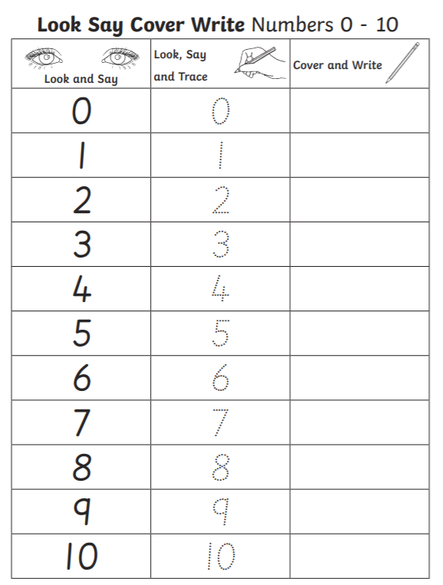
4.

