Name:
Can I describe a picture?
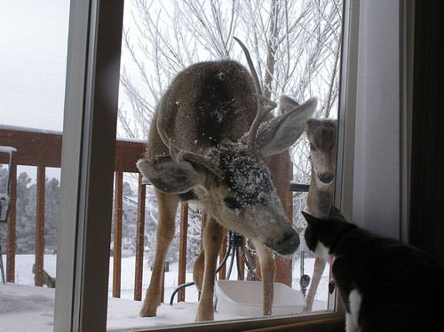 | reindeer  antlers  snow  tree  window  black white  brown  eyes ears  nose face  legs  light  dark  outside  inside

 |  | ABC |  |  | 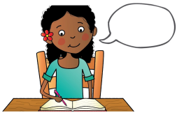
say the sentence | baby bird | capital letters | finger spaces | full stops | read your writing

