Literacy – Summer 1 week 5 19.05.2020
*worksheets can be found below
1 | Have a look at all the people who help us. Can you label what they are wearing or what equipment they are holding? (below)
2 | Now that you have had a chance to look at some of the people who help us and the jobs they do, have a think about what job you would like to do or who you would like to be when you are older and why? Use the worksheet below to help you start off. Once you have done this, can you act out the person you want to be? Use the clothes you have to try and dress up as this person and do the jobs that they do!
3 | Think about all the people you come across who help us. Choose one of these people – it might be a doctor, a policeman, a vet or anyone else! Have a go at describing this person. Remember all the descriptive writing words you have learnt! Once you have done your writing, have a go at drawing this person too.
4 | Handwriting – It is time to practice some handwriting. This week, you will be practicing ‘c’ and ‘a’. Get yourself a plain sheet of paper and off you go. There is a worksheet below to help you get started. For an extra challenge, write some sentences using the words on the sheet.
5 | Carry on building your model of an emergency vehicle. If you have already finished doing this, make an emergency worker to go inside it! Be as creative as you can and use your descriptive writing work to help you.

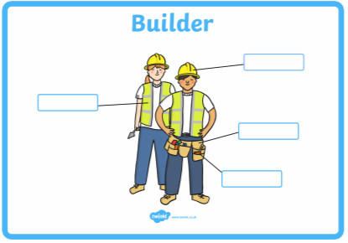

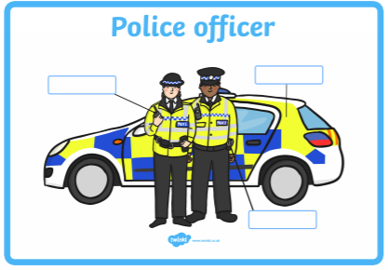

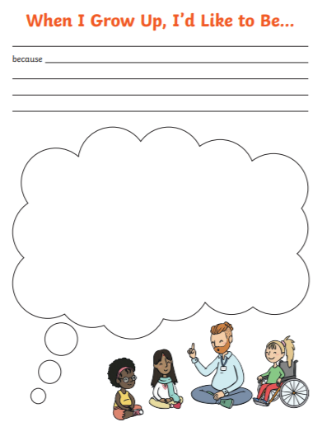

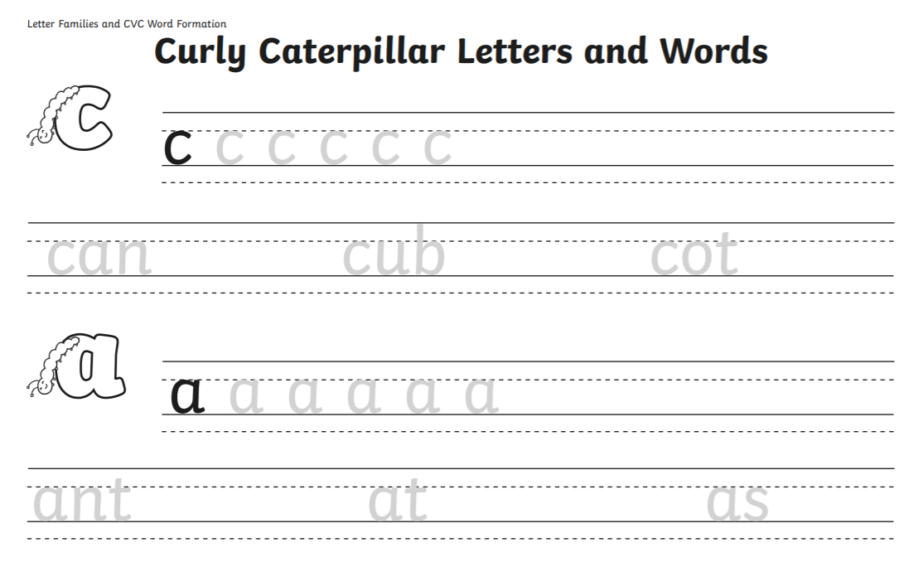

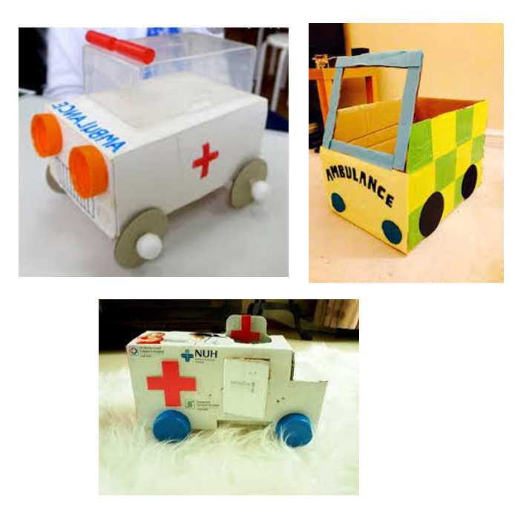
5.

