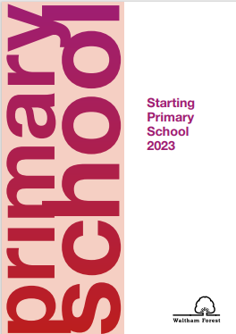
Reception places for September 2023
If your child was born between 1st September 2018 and 31st August 2019 you will need to apply for a Reception school place. You do not automatically receive a place if your child is currently in our nursery. The Eadmissions website opened on 1st September 2022 and will remain open for applications until 15th January 2023.
The process is all on line and you can access Eadmissions on https://www.eadmissions.org.uk/ . Waltham Forest has an information booklet at https://www.walthamforest.gov.uk/sites/default/files/2022-09/Starting%20Primary%20School%202023%20v4.pdf

Come and visit us at one of our Open Days to view the Reception classes and meet us!
Tuesday 11th October 2022 @ 10-11am
Saturday 15th October 2022 @10-11am
Wednesday 2nd November 2022 @ 1-2pm

We look forward to seeing you!

