Who was Roald Dahl? | Create a timeline for Roald Dahl’s stories:  http://www.roalddahl.com/roald-dahl/stories/1940s | If you could visit Willy Wonka’s chocolate factory, what would you ask him? Can you ask open ended questions? | Write about your favourite Roald Dahl character. What do you like about them? | Make a word search that includes characters from Roald Dahl’s books. | Follow the Roald Dahl blog!  http://www.roalddahl.com/blog/2015/october/i-want-it-now-october-2015
Design your dream chocolate bar. What is so unique about it? | Roald Dahl made up his own crazy words:  http://wonderfuldahl.blogspot.co.uk/p/dahl-dictionary.html  Can you create some of your own? | When was chocolate invented? | Visit the library with your family and read a Roald Dahl story! | Create a timeline for Roald Dahl’s life:  http://www.roalddahl.com/roald-dahl/timeline/1910s | What does ‘Fairtrade’ mean?
Who was Quentin Blake? What did he do? | Visit the amazing Roald Dahl museum in Great Missenden. Find the address here: http://www.roalddahl.com/home | Write an imaginary recipe for your dream chocolate pudding! | Who brought chocolate to the UK? How? | Make a list of chocolate bar names. What is your favourite? | Make a map of where chocolate grows around the world. What do you notice?
Create a fact-file about the Cadbury family | Make a chocolate cake at home. Take photos! Can you write the recipe for it? | Illustrate a Roald Dahl character of your choice in the style of Quentin Blake | Make a model of Willy Wonka’s Chocolate Factory. What materials did you use? | Watch the movie! Can you summarise the main points? What was your favourite part? | 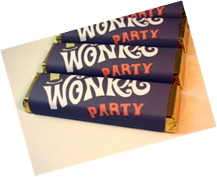  How is chocolate made today?
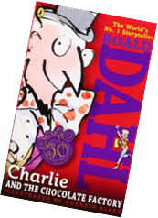
Year 4 Homework Project: Charlie and the Chocolate Factory

