Timetable week commencing 27/04/2020

Literacy: https://www.literacyshed.com/dreamgiver.html

- Describe the picture of the Dreamgiver using similes and metaphors. E.g. he looked like a firefly…. He was as bright as the morning sun. Who do you think he is? What does he do? What are his character traits look like?
- Can you think of some objects that you would like the Dreamgiver to crack his egg onto and describe the dreams that happened afterwards. Write is 1st or 3rd person.
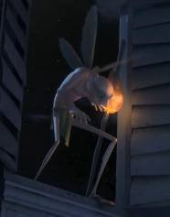

Challenge: Make up their own Dreamgiver, what does he look like? How does he give the dreams to people?

Grammar:
Expanded noun phrases:
See attached resources.

Reading: See readworks.org resources on the school website.

Maths: Follow the daily plans and complete the worksheet and self assess using the answers provided.
https://whiterosemaths.com/homelearning/year-5/
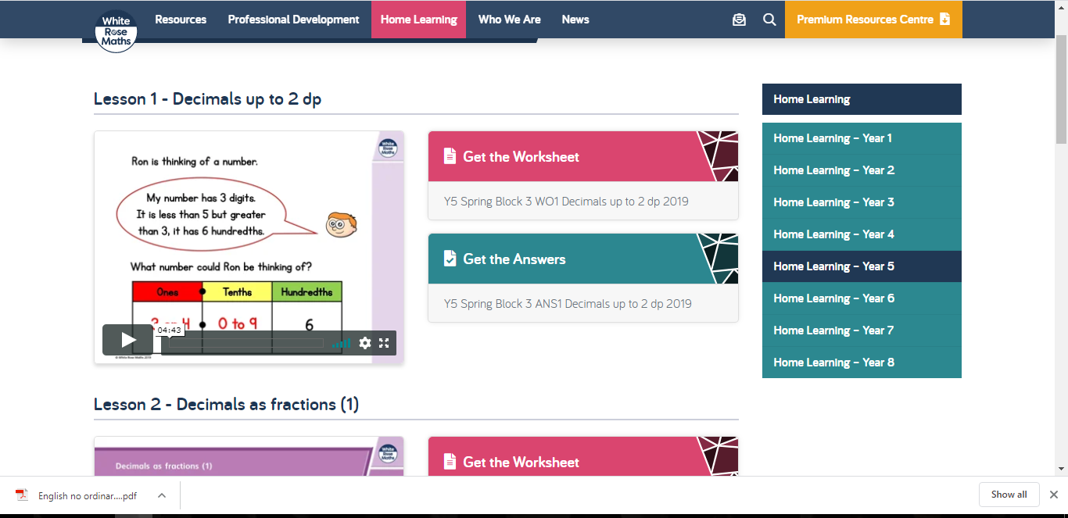

Topic:

- Design a Greek vase using the templates provided.
Challenge: Make and decorate your own Greek vase using household items.
