Phonics – Summer 1 Week 5 – 19.05.2020
*All worksheets can be found below.
Practice your sounds daily – set 1, 2 and 3 sounds
https://www.oxfordowl.co.uk/for-home/reading-owl/find-a-book/read-write-inc-phonics--1/phonics-pure-sounds-video
1 | ‘air’ work sheet – practice reading the ‘air’. When reading one of your books, can you spot some words that have the ‘air’ sound?  https://www.youtube.com/watch?v=ChGKNO_8u_g
2 | As yesterday  Write some sentences using these words – fair, chair, hair
3 | ‘ir’ worksheet – practice reading the ‘ir’. Look around your home. How many words can you find with the ‘ir’ sound around your house?  https://www.youtube.com/watch?v=91TKW0XILuc
4 | As yesterday  Write some sentences using these words – stir, dirt, bird
*Remember to read a book each day - either a book that you have at home or one of the e-books online. https://www.oxfordowl.co.uk/for-home/find-a-book/library-page/

Have a go at these green words!
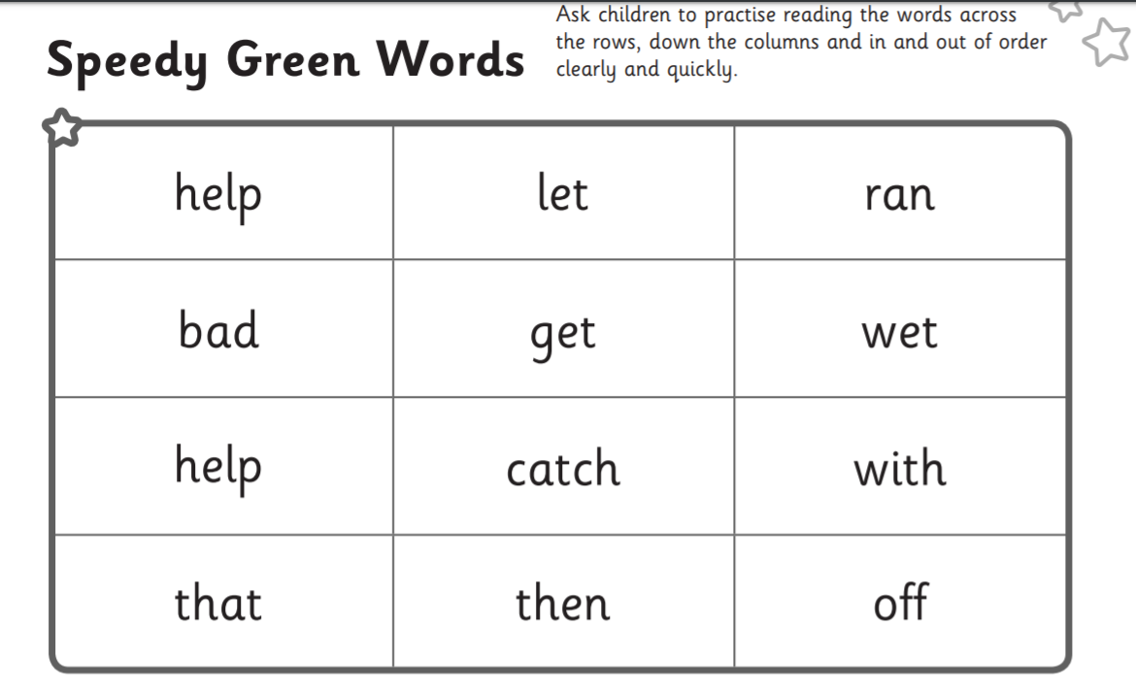

Have a go at reading these red words. Once you have read them, cover them up and have a go at writing them! There are 3 different red word worksheets so choose the one you would like to do and off you go!
Tricky
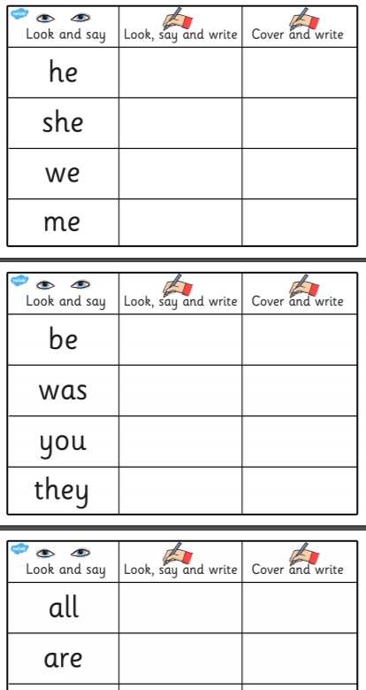

Trickier
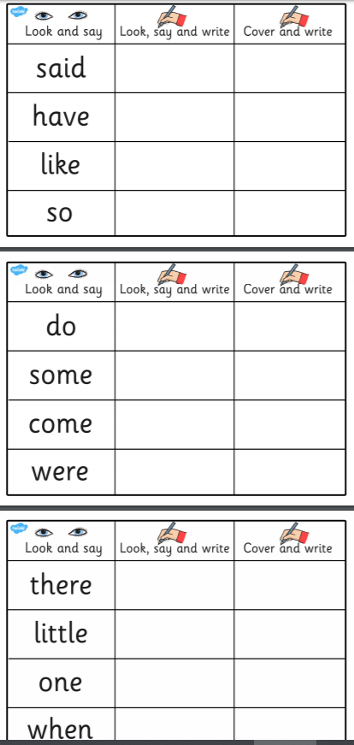

Trickiest
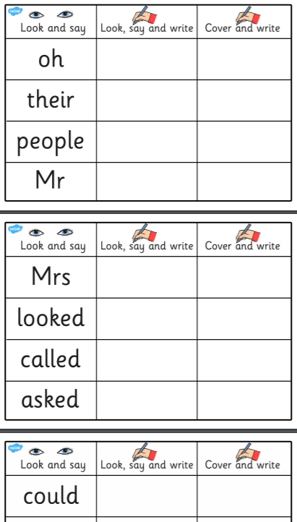

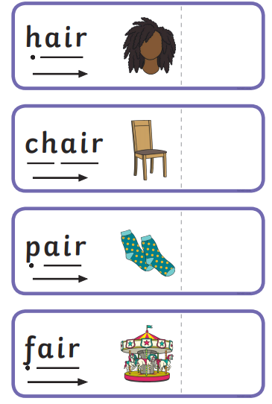
- ‘air’ worksheet

- ’ir’ worksheet
