Year 3 Spring Term 1

Homework Project

**Super**

**Sounds**

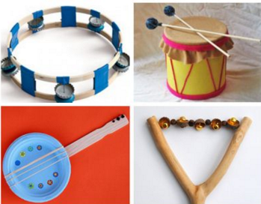

*Here are some places that might help you with your project:*

* Youtube
* Pinterest
* Hobby craft blog
* Twinkl

In Science, we’re learning about sound and how we can hear.

Your project homework is to design and make a musical instrument.

Look for materials around the home that could be used.

Be creative and have fun with this project!

**Due date: Friday 14th February 2019**