Year 2 Autumn Term 2

Homework Project

**LANDMARKS AROUND THE WORLD**

[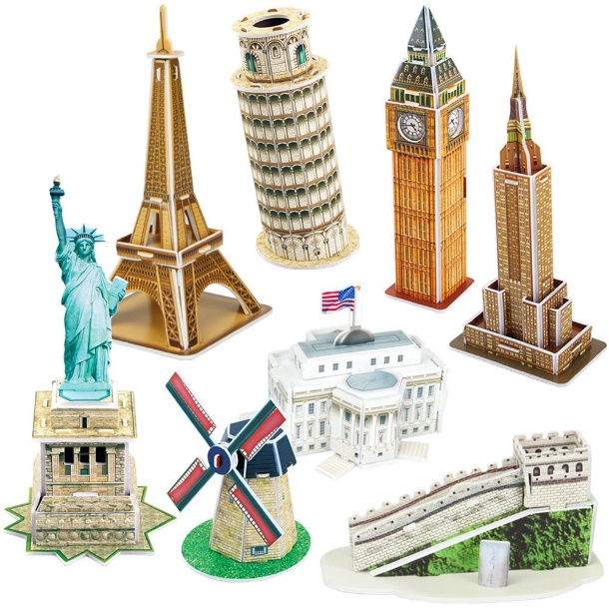](https://www.amazon.co.uk/CubicFun-Architecture-Building-Landmark-Instruction/dp/B07TGJ79NJ)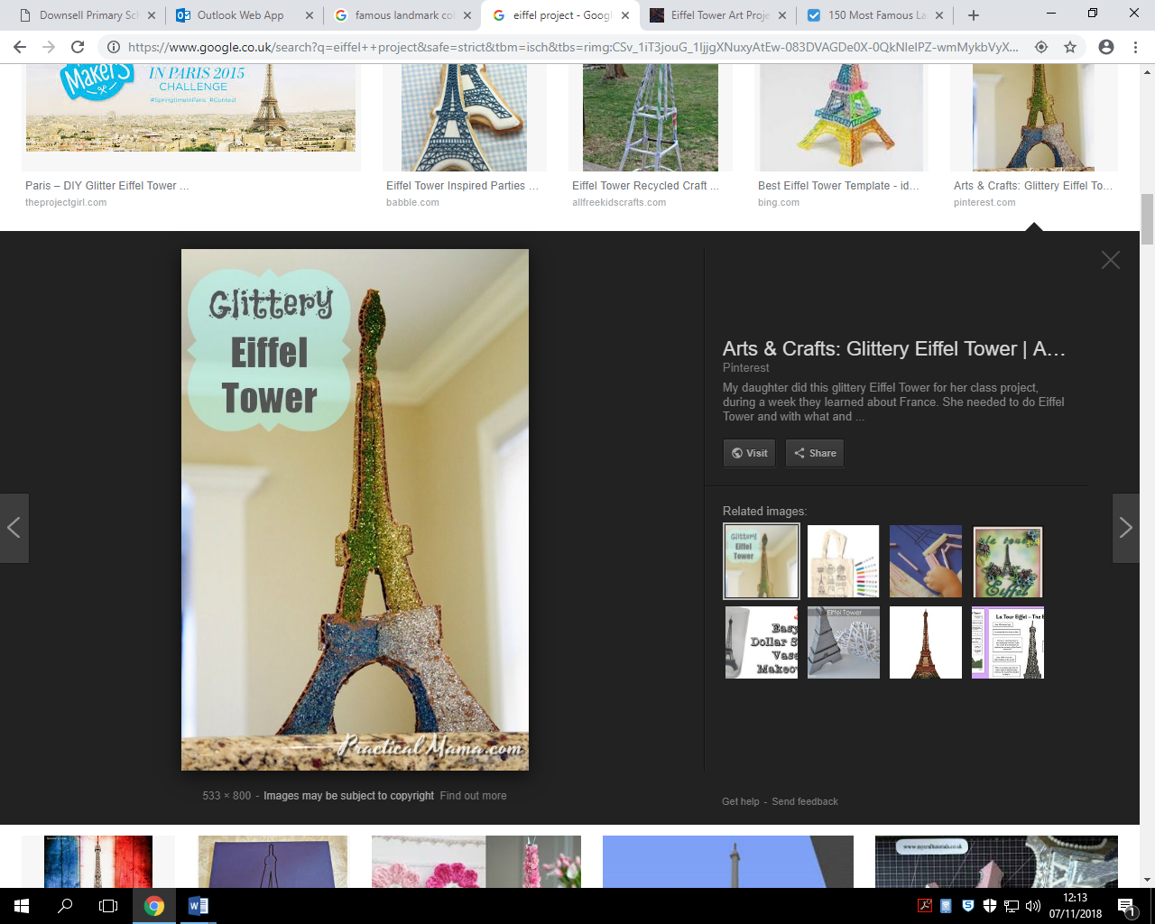

**Due date: Friday 6th December 2019**

**In Art, we have been exploring paper art. We will be designing and building our own 3D London Landmarks.**

**Your project is to build a famous 3D landmark from around the world using different materials.**

**Be creative! We look forward to seeing your wonderful Landmarks!**

***Here are some examples of famous landmarks you might want to build:***

* **Eiffel Tower**
* **Statue of Liberty**
* **Leaning Tower of Pisa**
* **Colosseum**
* **Empire State Building**
* **Hollywood Sign**
* **Golden Gate Bridge**