Year 3 Autumn Term 2 Week 3 and 4 Homework Project

**Magnificent Multiplication**

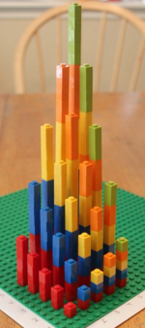

*Here are some places that might help you with your project:*

* <http://www.navigatingbyjoy.com/2014/03/02/make-multiplication-tower/>
* <https://naturalmath.com/2014/02/multiplicationtowers/>
* <https://frugalfun4boys.com/math-legos-3-d-multiplication-graph-activity/>
* <http://www.mathinyourfeet.com/math-by-design/multiplication-tower>

In Maths, we’re learning our timestables.

Your project is to make a 3D multiplication tower.

Be creative! We look forward to seeing your magnificent multiplication towers!

**Due date: Friday 23rd November 2018**