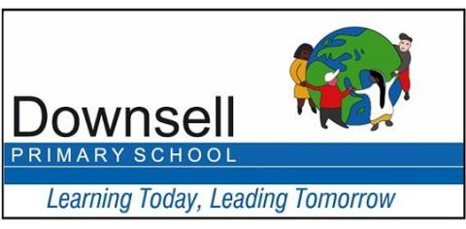

Applying for a Reception place for September 2021

If your child was born between 1 September 2016 and 31 August 2017 they are due to start in Reception class at a primary school from September 2021.

Full information on how to apply can be found in the Starting Primary School 2021 brochure which is available for parents to download from:
www.walthamforest.gov.uk/content/applying-primary-school-place

You must apply for a Reception place for your child even if they attend a school nursery or have an older brother or sister at your preferred school. If your child currently attends a nursery attached to a school this does not give them any priority for a place in Reception at that school.

Please apply online on www.eadmissions.org.uk
The closing date for applications is 15 January 2021

If you apply after the deadline your application will be considered as Late and you are less likely to be allocated one of your preferred schools.

Documents that have to be submitted with the application can be scanned and attached to the online application or emailed to admissions@walthamforest.gov.uk quoting the following:
- The child’s full name,
- Date of birth
- Application Reference Number.

